**Data Analytics with Tableau**

**Assignment – 3**

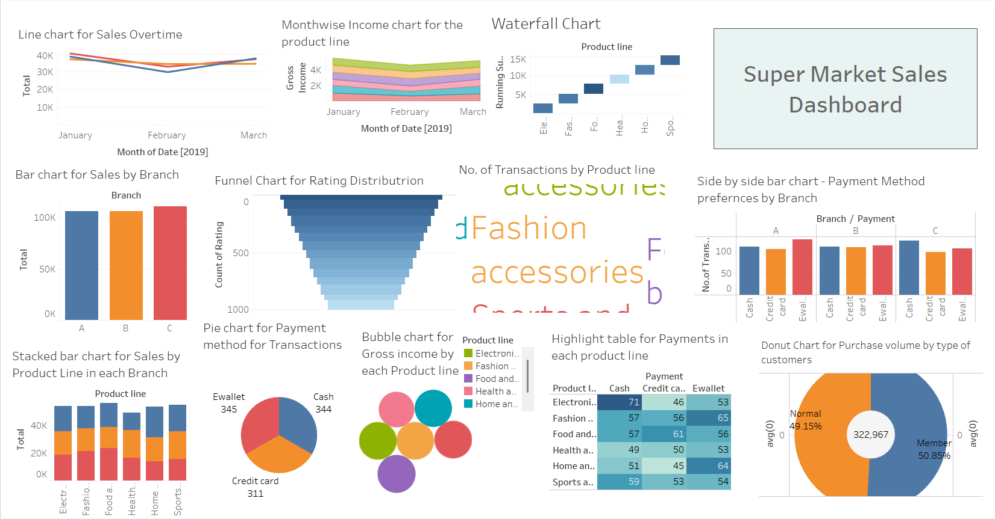Dashboard: